# Introduction

For the second lab we have the task to understand the life cycle of Activity and understand communication between different activities. In order to fulfill this task we develop a very simple game where we a main activity and try to match the colors of nine buttons in the main activity with the colors of 9 buttons in another activity. We are allowed to switch between activities the state of the main activity should remain the same when switching between activities.

# Main

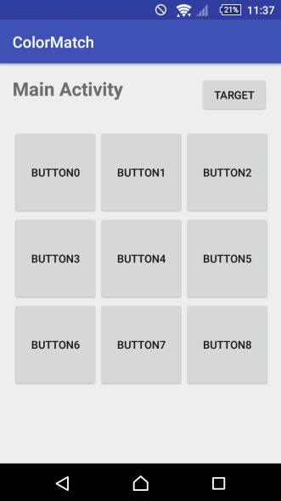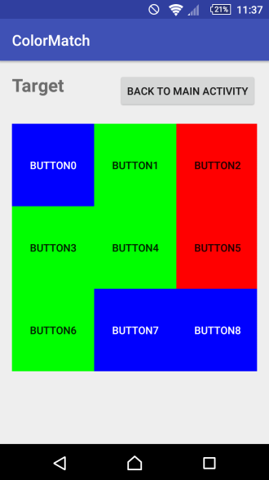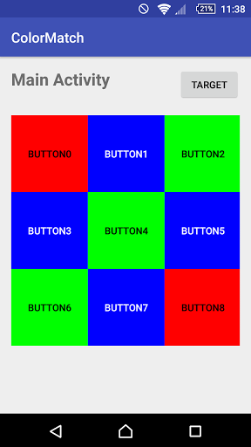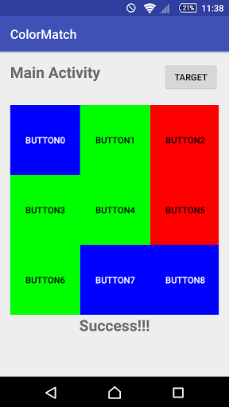

Figure Figure Figure Figure

The initial part for this lab was setting up the initial Main activity and the Target activity. Using what we learned in Lab 1 I used Relative Activity for the “Main Activity” text and “Target” button. For the 9 buttons I used a GridLayout using a 3x3 grid. The target activity was setup fairly similarly as the main activity with the only difference being the colors of the buttons being defined. Figure 1 shows the default for the main activity and figure 2 has the target activity.

The second main task for this lab was adding functionality for the 9 buttons to changed color and giving functionality to the button to see the target activity. The first thing to do is to add the target activity to the AndroidManifest.xml file. Button functionality in the main activity was setup by implementing View.onClickListener and overriding the onClick method to figure out which specific button was click. In the onCreate button listeners were setup and inside the onClick I find which button is clicked and if one of the 9 buttons is clicked setBackgroundColor is called to change the background color to represent the current state. In order to save the “state” of the 9 buttons onSaveInstanceState was used.

In the TargetActivity a single button is giving functionality, the button to return to the main activity. A button listener is setup for this button and once clicked closes the target activity and returns to the target activity.

Figure 3 shows a state where the main activity is after a couple different button presses and figure 4 shows the main activity once pattern matches the target activity pattern.

# Discussion and Conclusion

This was also a very enjoyable lab to work on. Main issue I had was forgetting to include the target activity in the AndroidManifest file. Other than that I didn’t have that many issues with the lab. The positives from this lab for me are giving buttons functionalities and switching between activities. I will continue to look forward to upcoming labs.

# Appendix A: Code

**MainActivity.java**

**package** com.jasonesquivel.colormatch;  
  
**import** android.graphics.Color;  
**import** android.support.v7.app.AppCompatActivity;  
**import** android.os.Bundle;  
**import** android.view.View;  
**import** android.widget.Button;  
**import** android.util.Log;  
**import** android.content.Intent;  
**import** android.widget.TextView;  
  
**import** org.w3c.dom.Text;  
  
**public class** MainActivity **extends** AppCompatActivity **implements** View.OnClickListener{  
 **private static final** String ***TAG*** = **"Jason Message:"**;  
 String[] **state** = {**"GRAY"**, **"GRAY"**, **"GRAY"**, **"GRAY"**, **"GRAY"**, **"GRAY"**, **"GRAY"**, **"GRAY"**, **"GRAY"** } ;  
 String[] **target**= {**"BLUE"**, **"GREEN"**, **"RED"**, **"GREEN"**, **"GREEN"**, **"RED"**, **"GREEN"**, **"BLUE"**, **"BLUE"**};  
  
 @Override  
 **protected void** onCreate(Bundle savedInstanceState) {  
 **if** (savedInstanceState != **null**) {  
 **state** = savedInstanceState.getStringArray(**"state"**);  
 }  
 **super**.onCreate(savedInstanceState);  
 setContentView(R.layout.***activity_main***);  
  
 Button targetButton = (Button) findViewById(R.id.***targetbutton***);  
 targetButton.setOnClickListener(**this**);  
  
 Button b0 = (Button) findViewById(R.id.***button0***);  
 b0.setOnClickListener(**this**);  
  
 Button b1 = (Button) findViewById(R.id.***button1***);  
 b1.setOnClickListener(**this**);  
  
 Button b2 = (Button) findViewById(R.id.***button2***);  
 b2.setOnClickListener(**this**);  
  
 Button b3 = (Button) findViewById(R.id.***button3***);  
 b3.setOnClickListener(**this**);  
  
 Button b4 = (Button) findViewById(R.id.***button4***);  
 b4.setOnClickListener(**this**);  
  
 Button b5 = (Button) findViewById(R.id.***button5***);  
 b5.setOnClickListener(**this**);  
  
 Button b6 = (Button) findViewById(R.id.***button6***);  
 b6.setOnClickListener(**this**);  
  
 Button b7 = (Button) findViewById(R.id.***button7***);  
 b7.setOnClickListener(**this**);  
  
 Button b8 = (Button) findViewById(R.id.***button8***);  
 b8.setOnClickListener(**this**);  
  
 }  
 @Override  
 **public void** onClick(View v) {  
 **switch** (v.getId()){  
 **case** R.id.***targetbutton***:  
 Intent intent=**new** Intent(MainActivity.**this**,TargetActivity.**class**);  
 startActivityForResult(intent, 1);  
 Log.*i*(***TAG***, **"Target Button Pressed"**);  
 **break**;  
 **case** R.id.***button0***:  
 buttonAction(R.id.***button0***,0);  
 Log.*i*(***TAG***, **"Button 0 Pressed"**);  
 **break**;  
 **case** R.id.***button1***:  
 buttonAction(R.id.***button1***,1);  
 Log.*i*(***TAG***, **"Button 1 Pressed"**);  
 **break**;  
 **case** R.id.***button2***:  
 buttonAction(R.id.***button2***,2);  
 Log.*i*(***TAG***, **"Button 2 Pressed"**);  
 **break**;  
 **case** R.id.***button3***:  
 buttonAction(R.id.***button3***,3);  
 Log.*i*(***TAG***, **"Button 3 Pressed"**);  
 **break**;  
 **case** R.id.***button4***:  
 buttonAction(R.id.***button4***,4);  
 Log.*i*(***TAG***, **"Button 4 Pressed"**);  
 **break**;  
 **case** R.id.***button5***:  
 buttonAction(R.id.***button5***,5);  
 Log.*i*(***TAG***, **"Button 5 Pressed"**);  
 **break**;  
 **case** R.id.***button6***:  
 buttonAction(R.id.***button6***,6);  
 Log.*i*(***TAG***, **"Button 6 Pressed"**);  
 **break**;  
 **case** R.id.***button7***:  
 buttonAction(R.id.***button7***,7);  
 Log.*i*(***TAG***, **"Button 7 Pressed"**);  
 **break**;  
 **case** R.id.***button8***:  
 buttonAction(R.id.***button8***,8);  
 Log.*i*(***TAG***, **"Button 8 Pressed"**);  
 **break**;  
 }  
 }  
  
 **private void** buttonAction(**int** buttonId, **int** stateId){  
 Button work = (Button) findViewById(buttonId);  
 Log.*i*(***TAG***, **"Button id "**+ buttonId + **"State id"** + stateId );  
 Log.*i*(***TAG***, **state**.toString());  
 **if**(**state**[stateId].equals(**"RED"**)) {  
 **state**[stateId] = **"BLUE"**;  
 work.setBackgroundColor(Color.***BLUE***);  
 work.setTextColor(Color.***WHITE***);  
 }  
 **else if**(**state**[stateId].equals(**"BLUE"**)) {  
 **state**[stateId] = **"GREEN"**;  
 work.setBackgroundColor(Color.***GREEN***);  
 work.setTextColor(Color.***BLACK***);  
 }  
 **else if**(**state**[stateId].equals(**"GREEN"**) || **state**[stateId].equals(**"GRAY"**)) {  
 **state**[stateId] = **"RED"**;  
 work.setBackgroundColor(Color.***RED***);  
 work.setTextColor(Color.***BLACK***);  
 }  
  
 showSuccess(checkTarget());  
 }  
  
 **private** Boolean checkTarget(){  
 **boolean** success = **true**;  
 **for**(**int** i = 0; i < **state**.**length**; i++){  
 **if**(!**state**[i].equals(**target**[i])){  
 success = **false**;  
 }  
 }  
 **return** success;  
 }  
  
 **private void** showSuccess(Boolean success){  
 **if**(success) {  
 TextView text = (TextView) findViewById(R.id.***success***);  
 text.setText(**"Success!!!"**);  
 }  
 }  
 @Override  
 **protected void** onStart() {  
 **super**.onStart();  
 Log.*i*(***TAG***, **"onStart"**);  
 }  
  
 @Override  
 **protected void** onResume() {  
 **super**.onResume();  
 Log.*i*(***TAG***, **"onResume"**);  
 }  
  
 @Override  
 **protected void** onPause() {  
 **super**.onPause();  
 Log.*i*(***TAG***, **"onPause"**);  
 }  
  
 @Override  
 **protected void** onStop() {  
 **super**.onStop();  
 Log.*i*(***TAG***, **"onStop"**);  
 }  
  
 @Override  
 **protected void** onDestroy() {  
 **super**.onDestroy();  
 Log.*i*(***TAG***, **"onDestroy"**);  
 }  
  
 @Override  
 **protected void** onSaveInstanceState(Bundle outState) {  
 **super**.onSaveInstanceState(outState);  
 outState.putStringArray(**"state"**, **state**);  
 Log.*i*(***TAG***, **"onSaveInstanceState"**);  
 }  
}

**TargetActivity.java**

**package** com.jasonesquivel.colormatch;  
  
**import** android.graphics.Color;  
**import** android.support.v7.app.AppCompatActivity;  
**import** android.os.Bundle;  
**import** android.view.View;  
**import** android.widget.Button;  
**import** android.util.Log;  
  
*/**  
 * Created by Jason Esquivel on 2/26/2017.  
 */***public class** TargetActivity **extends** AppCompatActivity{  
  
 **protected void** onCreate(Bundle savedInstanceState){  
  
 **super**.onCreate(savedInstanceState);  
 setContentView(R.layout.***activity_target***);  
  
 Button mainButton = (Button) findViewById(R.id.***mainbutton***);  
 mainButton.setOnClickListener(**mainListener**);  
 }  
 **private** Button.OnClickListener **mainListener** = **new** Button.OnClickListener(){ *//创建button listener* **public void** onClick(View v){  
 setResult(1);  
 finish();  
 *//Log.i(TAG, "CAO");* }  
 };  
}

**activity_main.xml**

*<?***xml version="1.0" encoding="utf-8"***?>*<**RelativeLayout xmlns:android="http://schemas.android.com/apk/res/android"  
 xmlns:tools="http://schemas.android.com/tools"  
 android:id="@+id/activity_main"  
 android:layout_width="match_parent"  
 android:layout_height="match_parent"  
 android:paddingBottom="@dimen/activity_vertical_margin"  
 android:paddingLeft="@dimen/activity_horizontal_margin"  
 android:paddingRight="@dimen/activity_horizontal_margin"  
 android:paddingTop="@dimen/activity_vertical_margin"  
 tools:context="com.jasonesquivel.colormatch.MainActivity"**>  
  
 <**TextView  
 android:id="@+id/maintext"  
 android:layout_width="wrap_content"  
 android:layout_height="wrap_content"  
 android:text="Main Activity"  
 android:textSize="24dp"  
 android:textStyle="bold"  
 android:layout_alignParentTop="true"  
 android:layout_alignParentLeft="true"**/>  
 <**Button  
 android:id="@+id/targetbutton"  
 android:layout_width="wrap_content"  
 android:layout_height="wrap_content"  
 android:text="Target"  
 android:layout_alignParentRight="true"  
 android:layout_alignParentTop="true"  
 android:layout_alignRight="@id/maintext"**/>  
 <**GridLayout  
 android:id="@+id/grid"  
 android:layout_width="wrap_content"  
 android:layout_height="wrap_content"  
 android:columnCount="3"  
 android:rowCount="3"  
 android:orientation="horizontal"  
 android:layout_below="@id/targetbutton"  
 android:layout_alignParentRight="true"  
 android:layout_alignParentLeft="true"  
 android:paddingTop="20dp"**>  
  
 <**Button  
 android:id="@+id/button0"  
 android:text="Button0"  
 android:layout_height="110dp"  
 android:layout_width="110dp"**/>  
 <**Button  
 android:id="@+id/button1"  
 android:text="Button1"  
 android:layout_height="110dp"  
 android:layout_width="110dp"**/>  
 <**Button  
 android:id="@+id/button2"  
 android:text="Button2"  
 android:layout_height="110dp"  
 android:layout_width="110dp"**/>  
 <**Button  
 android:id="@+id/button3"  
 android:text="Button3"  
 android:layout_height="110dp"  
 android:layout_width="110dp"**/>  
 <**Button  
 android:id="@+id/button4"  
 android:text="Button4"  
 android:layout_height="110dp"  
 android:layout_width="110dp"**/>  
 <**Button  
 android:id="@+id/button5"  
 android:text="Button5"  
 android:layout_height="110dp"  
 android:layout_width="110dp"**/>  
 <**Button  
 android:id="@+id/button6"  
 android:text="Button6"  
 android:layout_height="110dp"  
 android:layout_width="110dp"**/>  
 <**Button  
 android:id="@+id/button7"  
 android:text="Button7"  
 android:layout_height="110dp"  
 android:layout_width="110dp"**/>  
 <**Button  
 android:id="@+id/button8"  
 android:text="Button8"  
 android:layout_height="110dp"  
 android:layout_width="110dp"**/>  
 </**GridLayout**>  
 <**TextView  
 android:id="@+id/success"  
 android:layout_width="match_parent"  
 android:layout_height="wrap_content"  
 android:text=""  
 android:textSize="24dp"  
 android:textStyle="bold"  
 android:layout_below="@+id/grid"  
 android:textAlignment="center"**/>  
</**RelativeLayout**>

**Activity_target.xml**

*<?***xml version="1.0" encoding="utf-8"***?>*<**RelativeLayout xmlns:android="http://schemas.android.com/apk/res/android"  
 xmlns:tools="http://schemas.android.com/tools"  
 android:id="@+id/activity_target"  
 android:layout_width="match_parent"  
 android:layout_height="match_parent"  
 android:paddingBottom="@dimen/activity_vertical_margin"  
 android:paddingLeft="@dimen/activity_horizontal_margin"  
 android:paddingRight="@dimen/activity_horizontal_margin"  
 android:paddingTop="@dimen/activity_vertical_margin"  
 tools:context="com.jasonesquivel.colormatch.MainActivity"**>  
  
 <**TextView  
 android:id="@+id/targettext"  
 android:layout_width="wrap_content"  
 android:layout_height="wrap_content"  
 android:text="Target"  
 android:textSize="24dp"  
 android:textStyle="bold"  
 android:layout_alignParentTop="true"  
 android:layout_alignParentLeft="true"**/>  
 <**Button  
 android:id="@+id/mainbutton"  
 android:layout_width="wrap_content"  
 android:layout_height="wrap_content"  
 android:text="Back to Main Activity"  
 android:layout_alignParentRight="true"  
 android:layout_alignParentTop="true"  
 android:layout_alignRight="@id/targettext"**/>  
 <**GridLayout  
 android:layout_width="wrap_content"  
 android:layout_height="wrap_content"  
 android:columnCount="3"  
 android:rowCount="3"  
 android:orientation="horizontal"  
 android:layout_below="@id/mainbutton"  
 android:layout_alignParentRight="true"  
 android:layout_alignParentLeft="true"  
 android:paddingTop="20dp"**>  
  
 <**Button  
 android:id="@+id/button0"  
 android:text="Button0"  
 android:layout_height="110dp"  
 android:layout_width="110dp"  
 android:background="#0000ff"  
 android:textColor="#ffffff"**/>  
 <**Button  
 android:id="@+id/button1"  
 android:text="Button1"  
 android:layout_height="110dp"  
 android:layout_width="110dp"  
 android:background="#00ff00"**/>  
 <**Button  
 android:id="@+id/button2"  
 android:text="Button2"  
 android:layout_height="110dp"  
 android:layout_width="110dp"  
 android:background="#ff0000"**/>  
 <**Button  
 android:id="@+id/button3"  
 android:text="Button3"  
 android:layout_height="110dp"  
 android:layout_width="110dp"  
 android:background="#00ff00"**/>  
 <**Button  
 android:id="@+id/button4"  
 android:text="Button4"  
 android:layout_height="110dp"  
 android:layout_width="110dp"  
 android:background="#00ff00"**/>  
 <**Button  
 android:id="@+id/button5"  
 android:text="Button5"  
 android:layout_height="110dp"  
 android:layout_width="110dp"  
 android:background="#ff0000"**/>  
 <**Button  
 android:id="@+id/button6"  
 android:text="Button6"  
 android:layout_height="110dp"  
 android:layout_width="110dp"  
 android:background="#00ff00"**/>  
 <**Button  
 android:id="@+id/button7"  
 android:text="Button7"  
 android:layout_height="110dp"  
 android:layout_width="110dp"  
 android:background="#0000ff"  
 android:textColor="#ffffff"**/>  
 <**Button  
 android:id="@+id/button8"  
 android:text="Button8"  
 android:layout_height="110dp"  
 android:layout_width="110dp"  
 android:background="#0000ff"  
 android:textColor="#ffffff"**/>  
 </**GridLayout**>  
</**RelativeLayout**>

**AndroidManifest.xml**

*<?***xml version="1.0" encoding="utf-8"***?>*<**manifest xmlns:android="http://schemas.android.com/apk/res/android"  
 package="com.jasonesquivel.colormatch"**>  
  
 <**application  
 android:allowBackup="true"  
 android:icon="@mipmap/ic_launcher"  
 android:label="@string/app_name"  
 android:supportsRtl="true"  
 android:theme="@style/AppTheme"**>  
 <**activity  
 android:name=".MainActivity"**>  
 <**intent-filter**>  
 <**action android:name="android.intent.action.MAIN"** />  
  
 <**category android:name="android.intent.category.LAUNCHER"** />  
 </**intent-filter**>  
 </**activity**>  
 <**activity  
 android:name=".TargetActivity"**>  
 </**activity**>  
  
  
 </**application**>  
  
</**manifest**>